Task Roulette

SCRUM Diagram (Initial)

**COP 4331, Spring, 2014**

**Team Name**: MADNESS

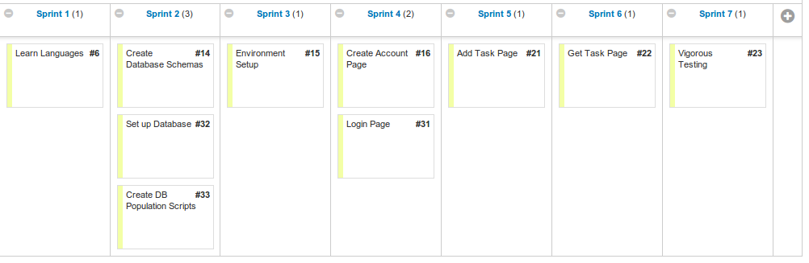

Figure 1: Sprint Timeline

----------------------------------------------------------------------------------------------------------------------------

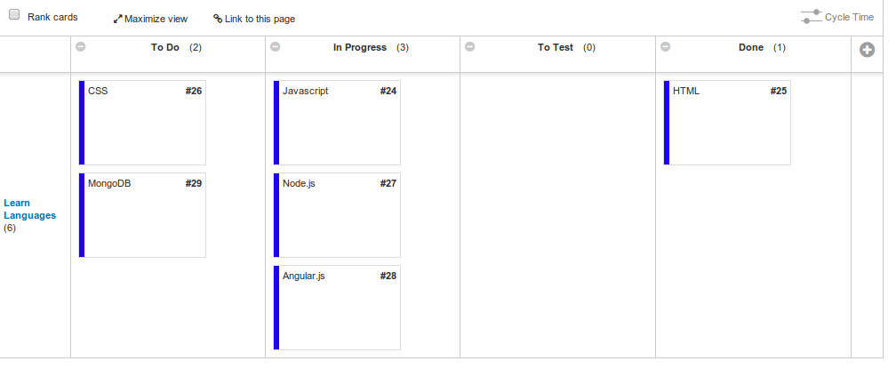

Figure 2: Tasks for Sprint 1